Lab3- Operational Amplifiers Part 1

Faizan Bangash

Section 504

09-24-2018

**Calculations –**

1. • Supply Voltage - (Absolute Maximum Rating) -18V , 18 V

• Power Consumption - .014 W

• Input Resistance - @25 C - 2 M(ohms) minimum

• Input Offset Voltage - @25 C – 1 mV

• Output Resistance -@25 C – 75 ohms

• Input Offset Current -@25 C – 20 nA

• Voltage Gain – 106 dB

• Bandwidth – 1.2 MHz

• Slew Rate - .5 V/us

1. 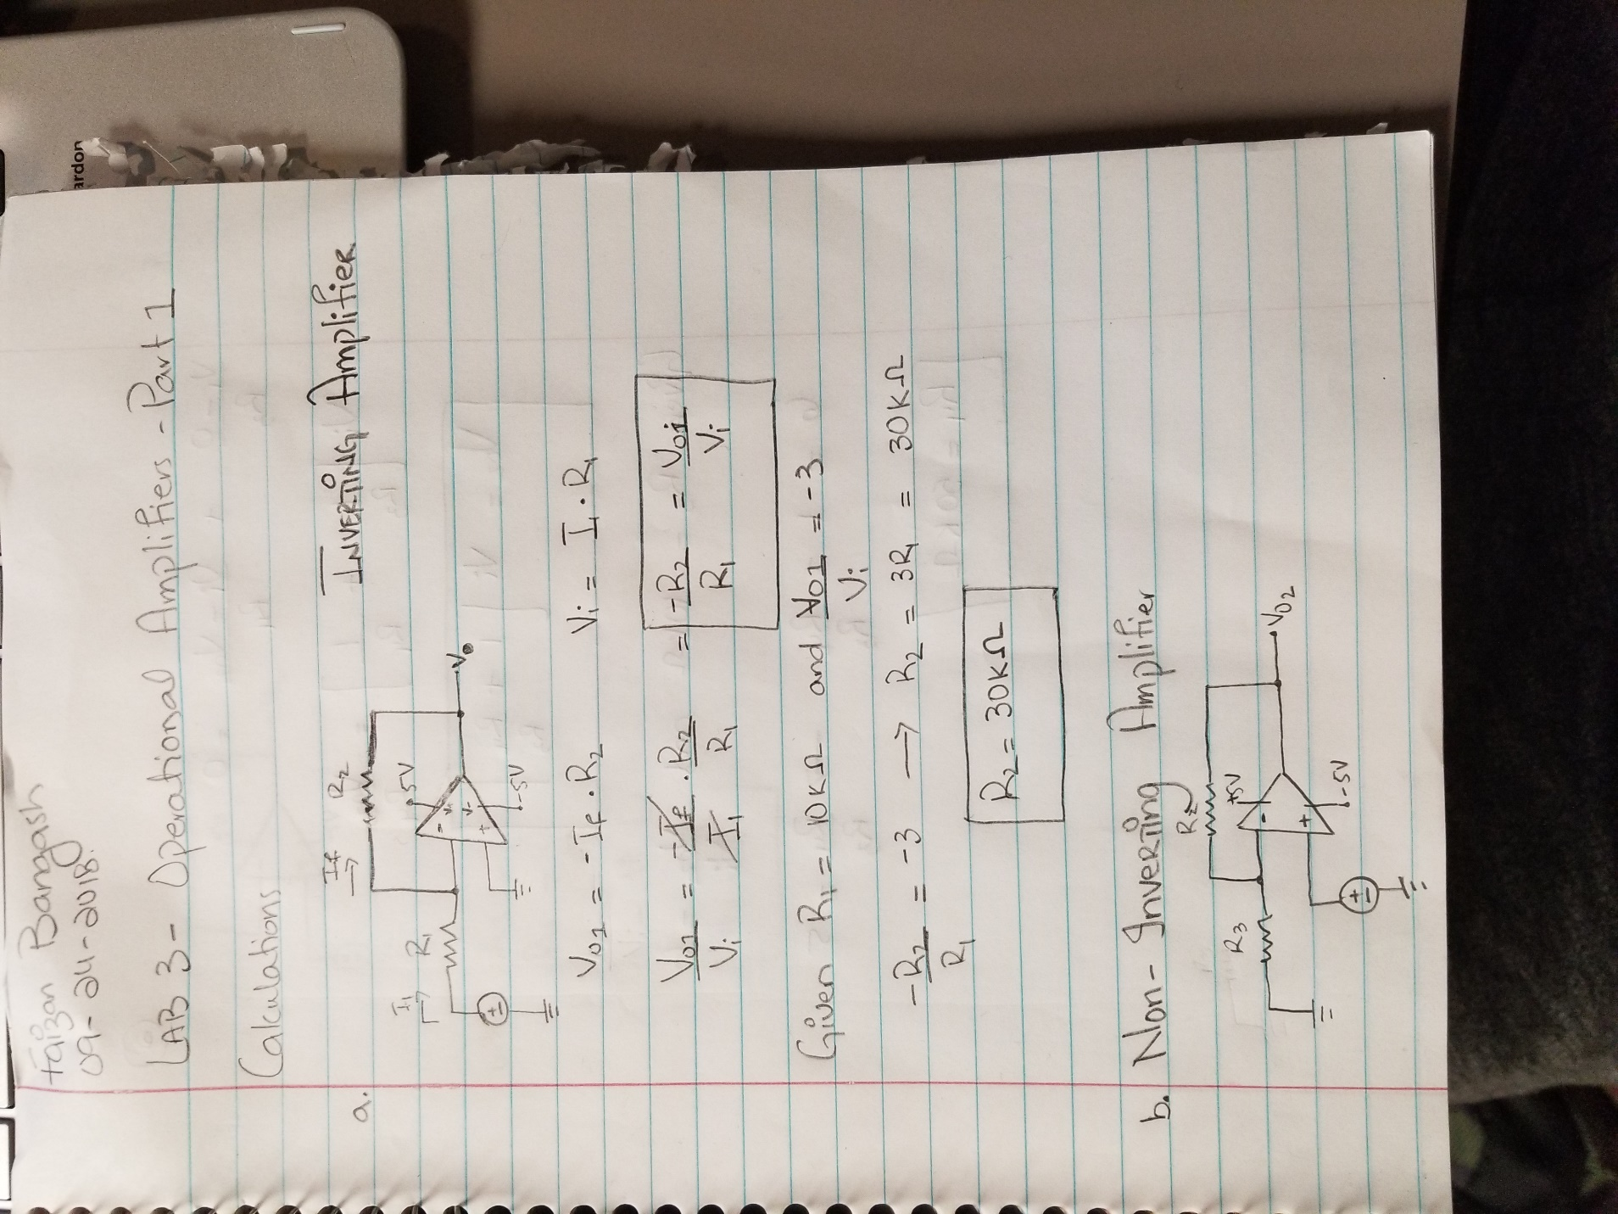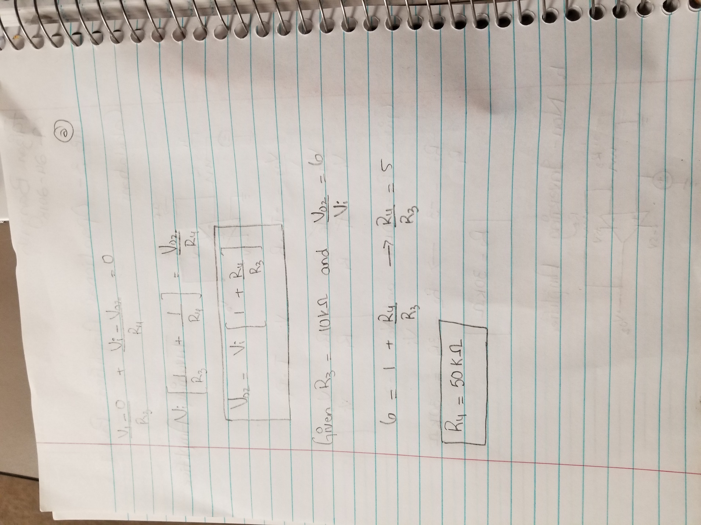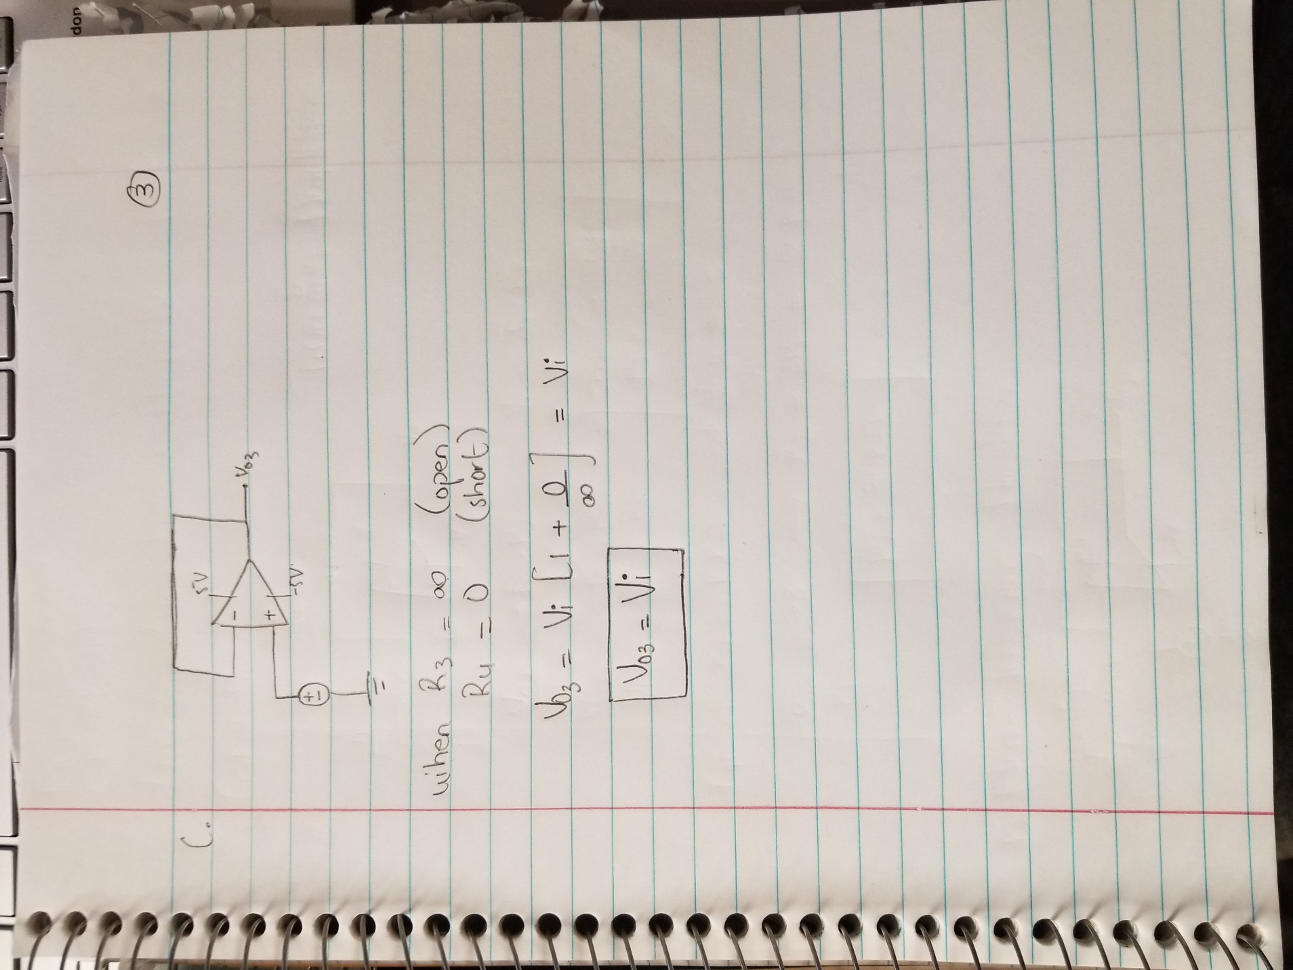

**Simulations –**

**Inverting Amplifier –**

 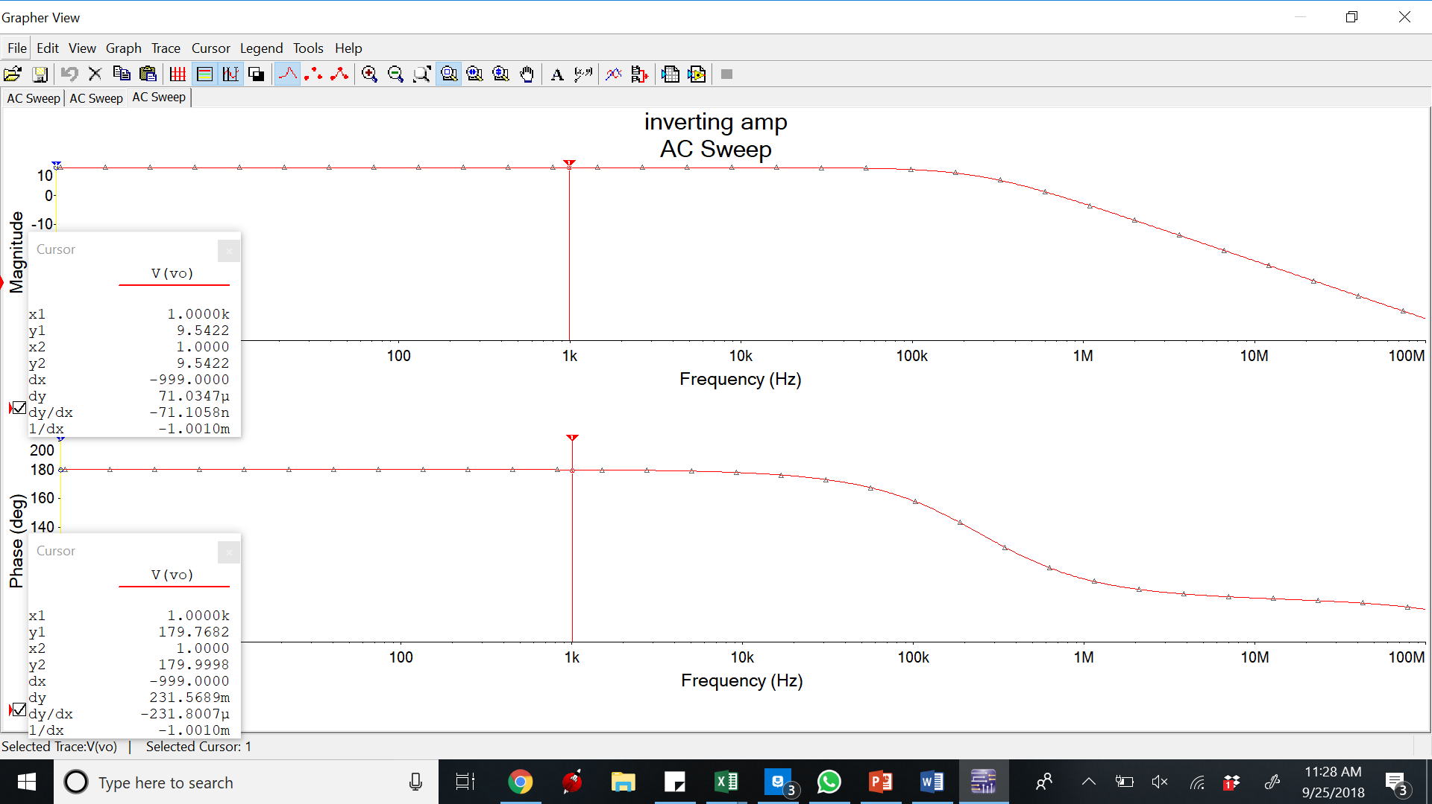

**Bode Plot**

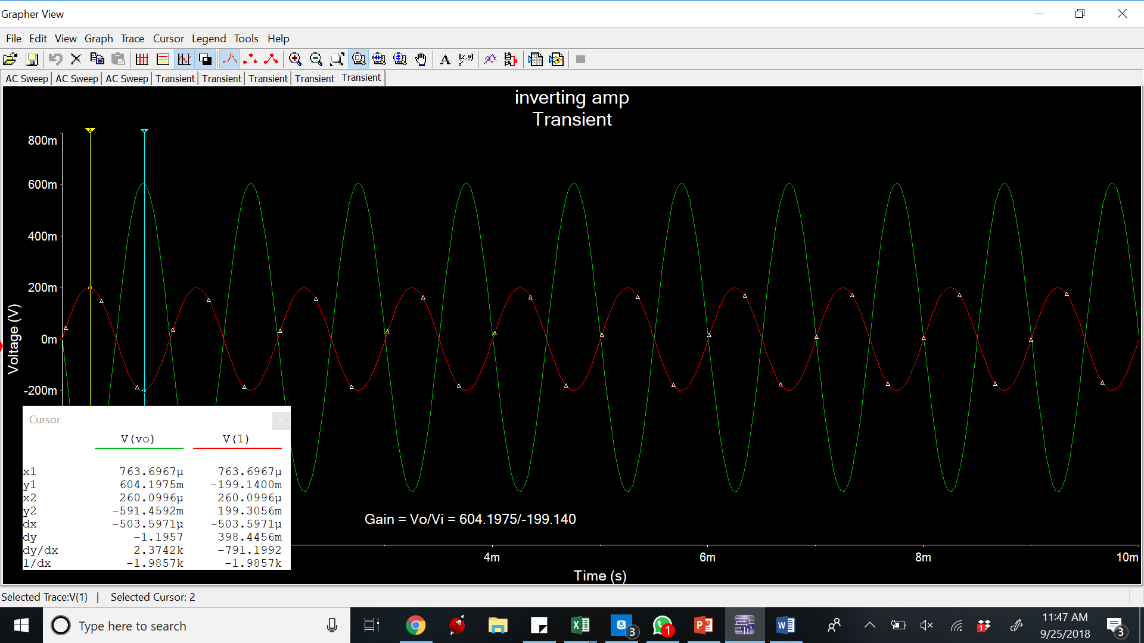

**Time Domain waveform**

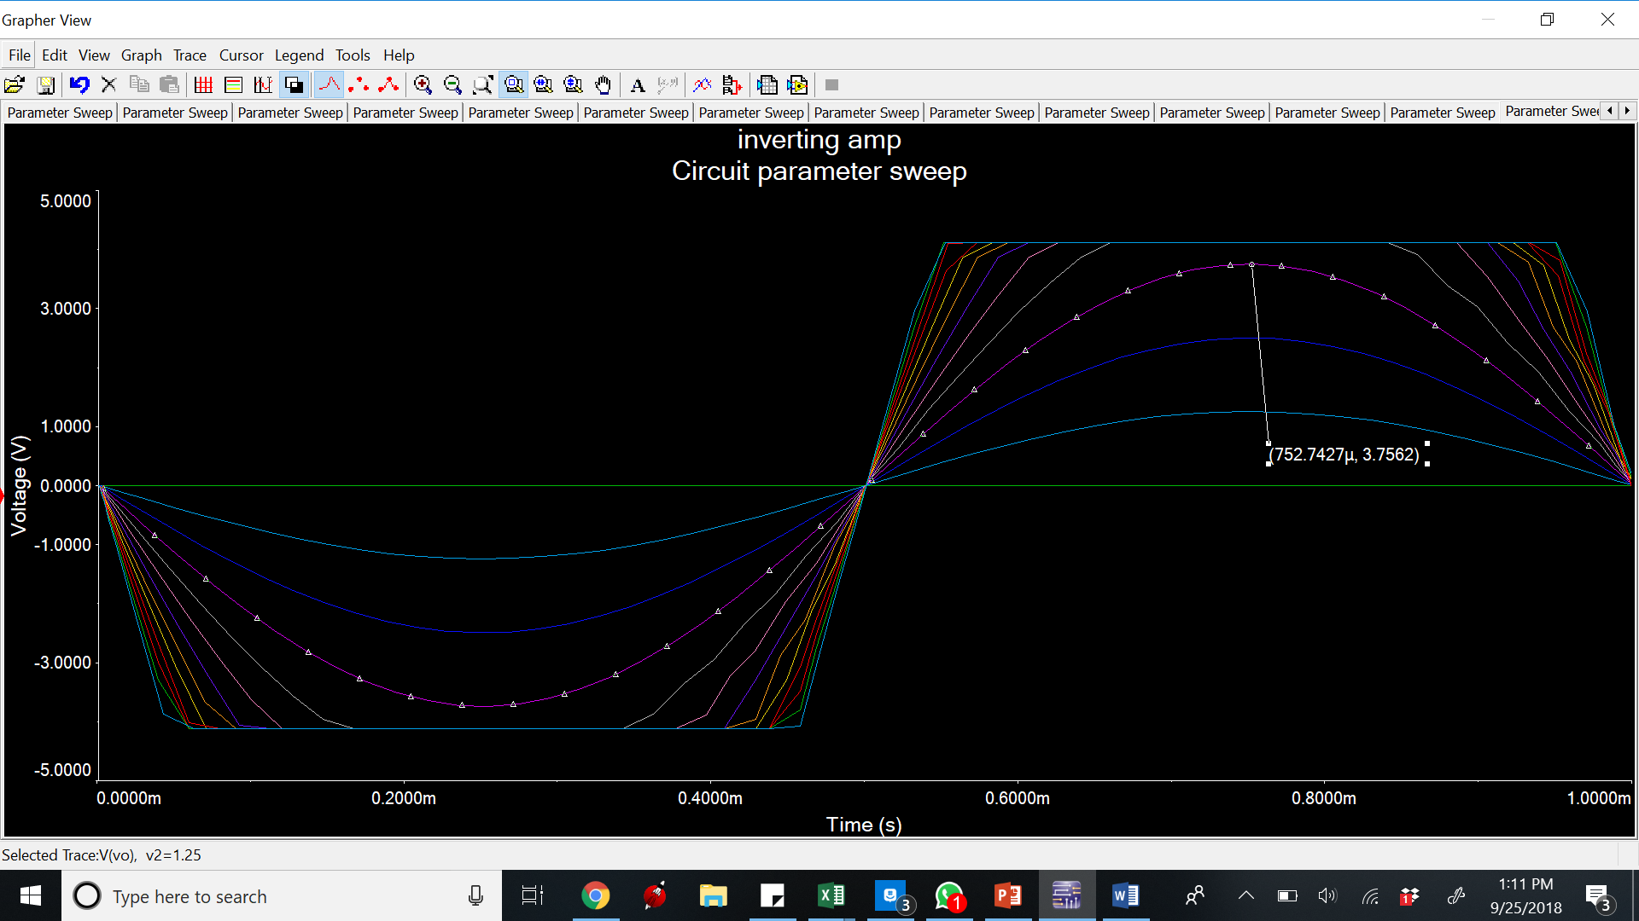

**Parameter sweep**

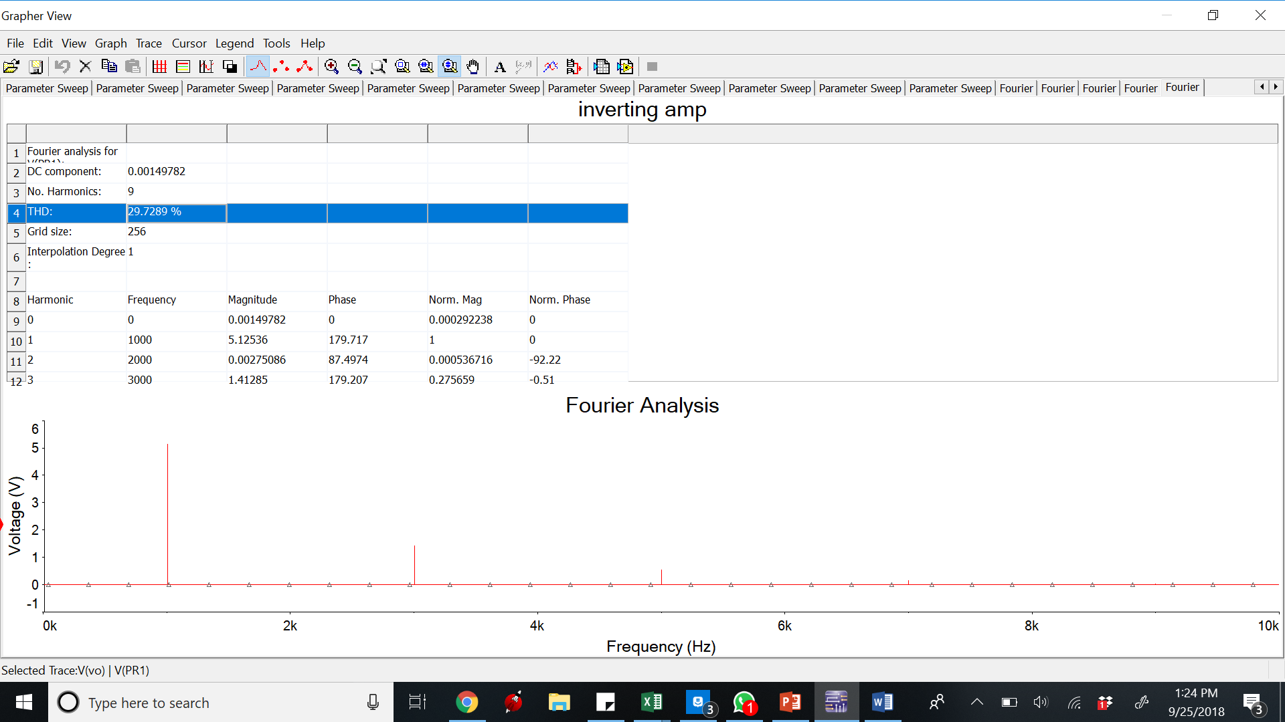

**total harmonic distortion (THD)**

**Non-Inverting Amplifier –**



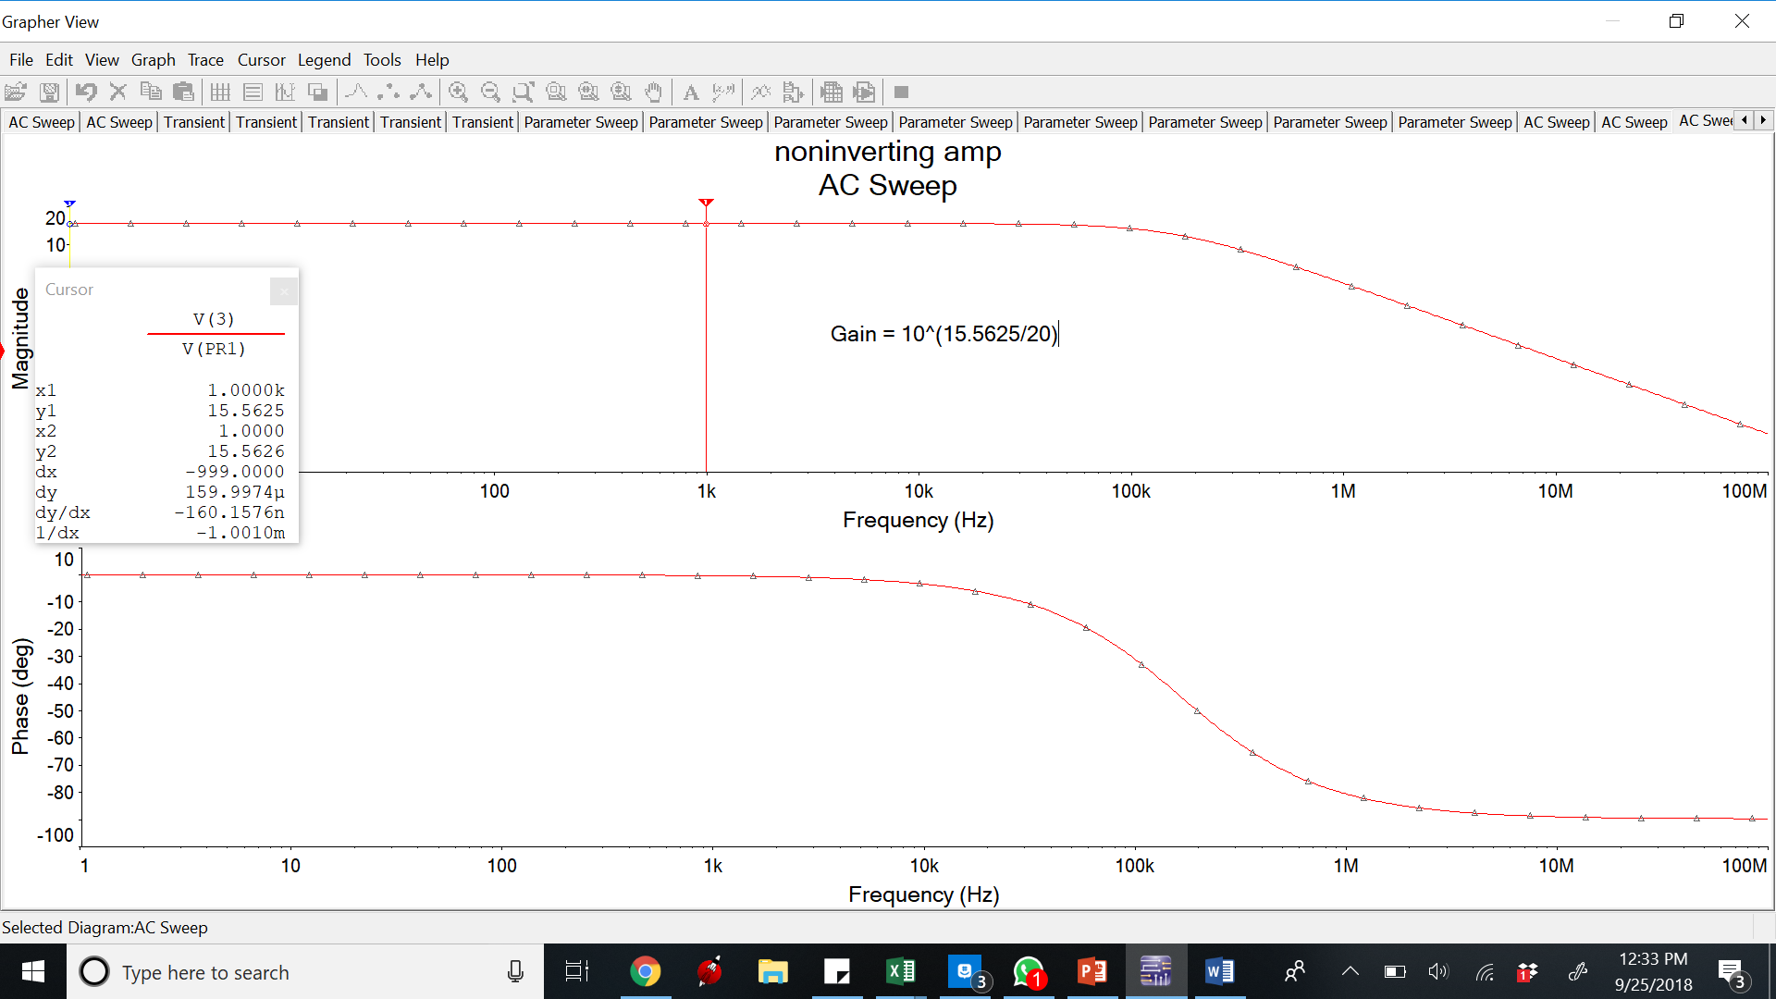 **Bode Plot**

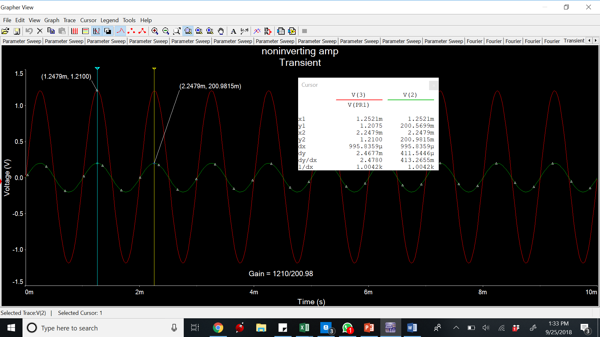

**Time Domain waveform**

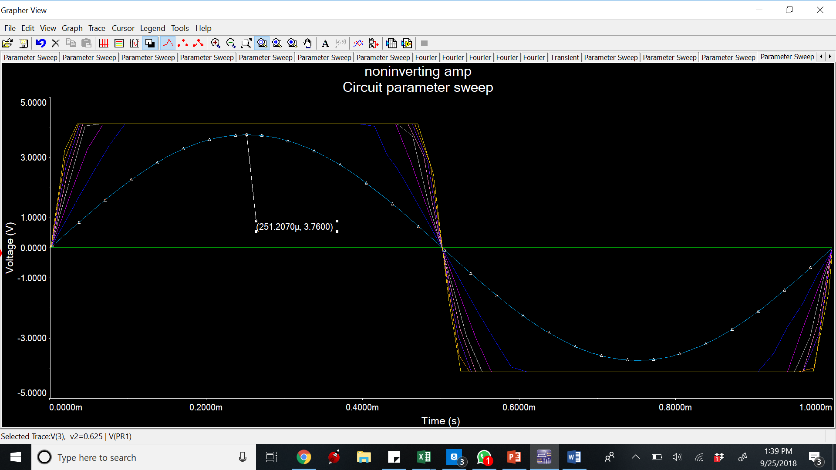

**Parameter sweep**

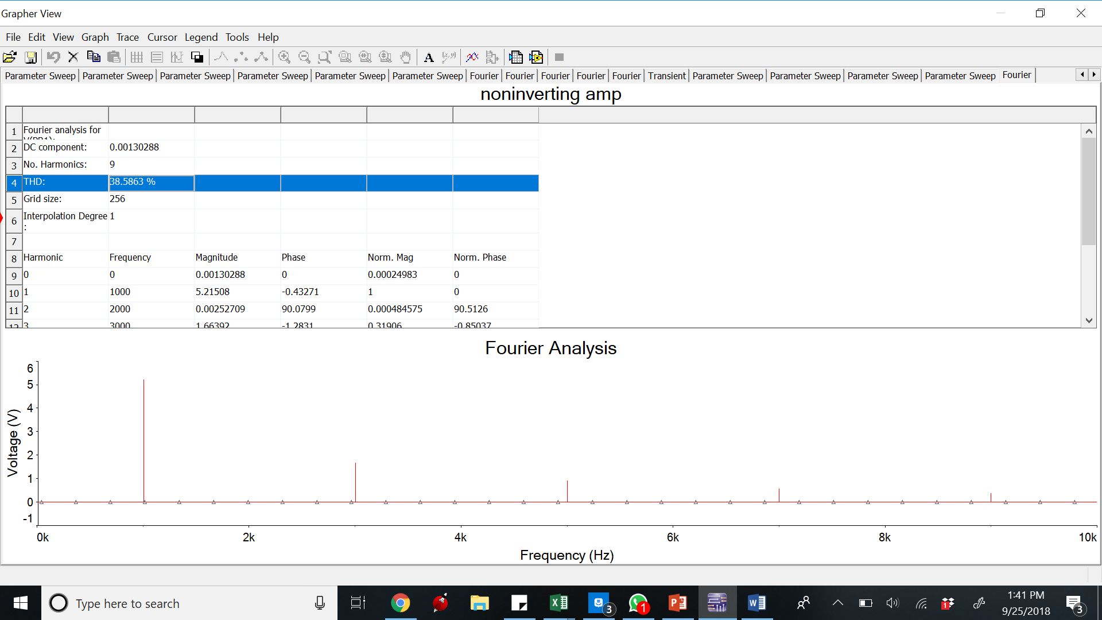 **total harmonic distortion (THD)**

**Buffer –**

 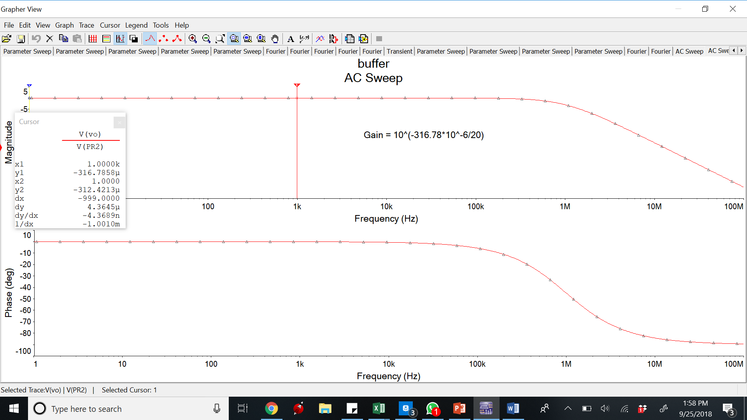**Bode Plot**

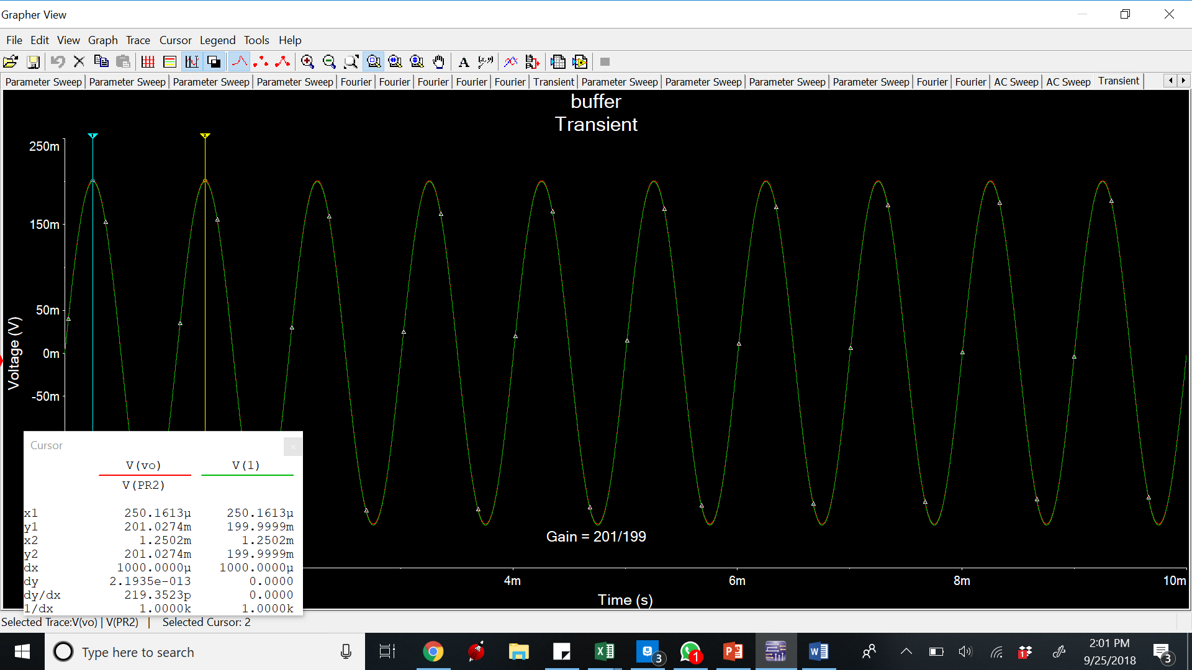**Time Domain waveform**

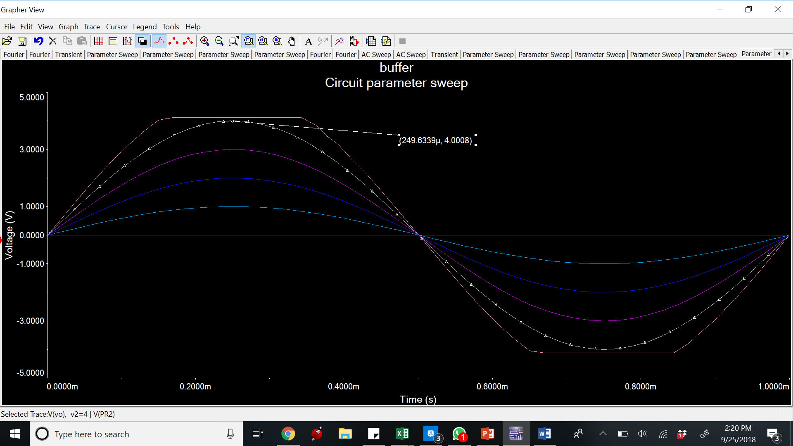**Parameter sweep**

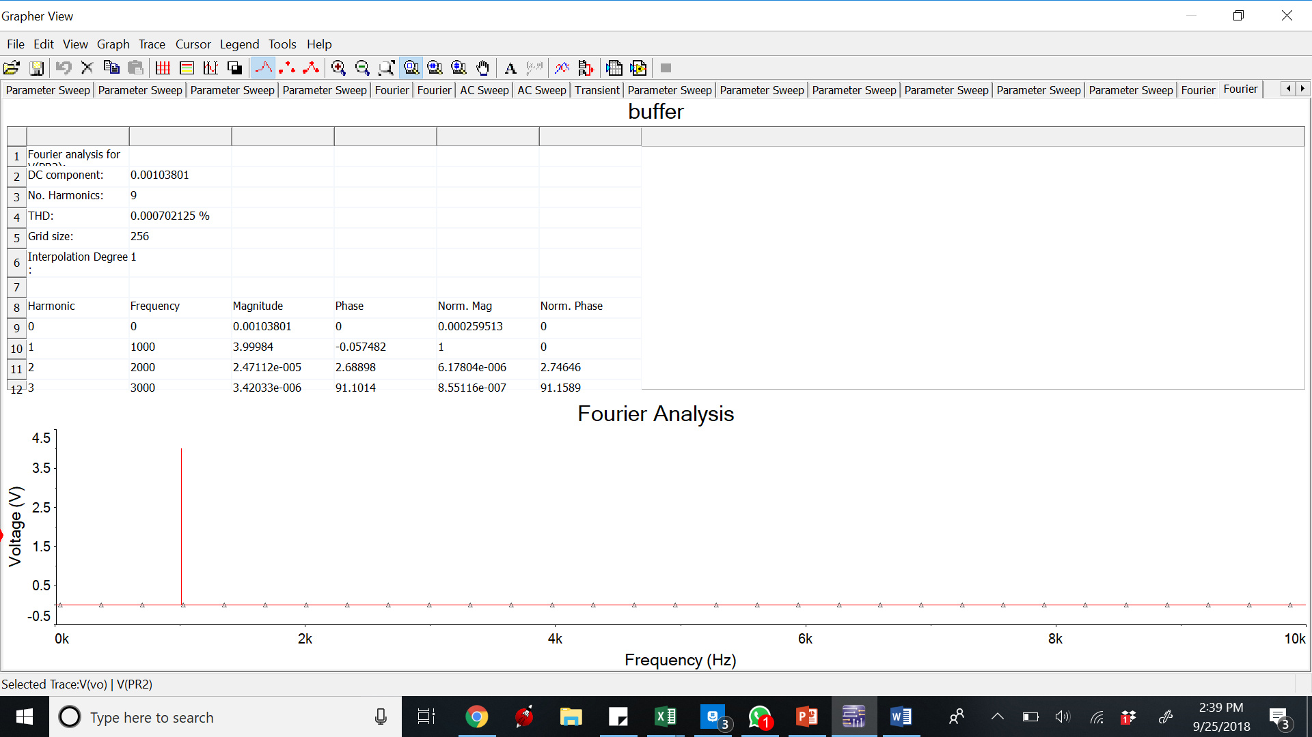

**total harmonic distortion (THD)**

**Measurement –**

Input Offset Current

Positive Terminal

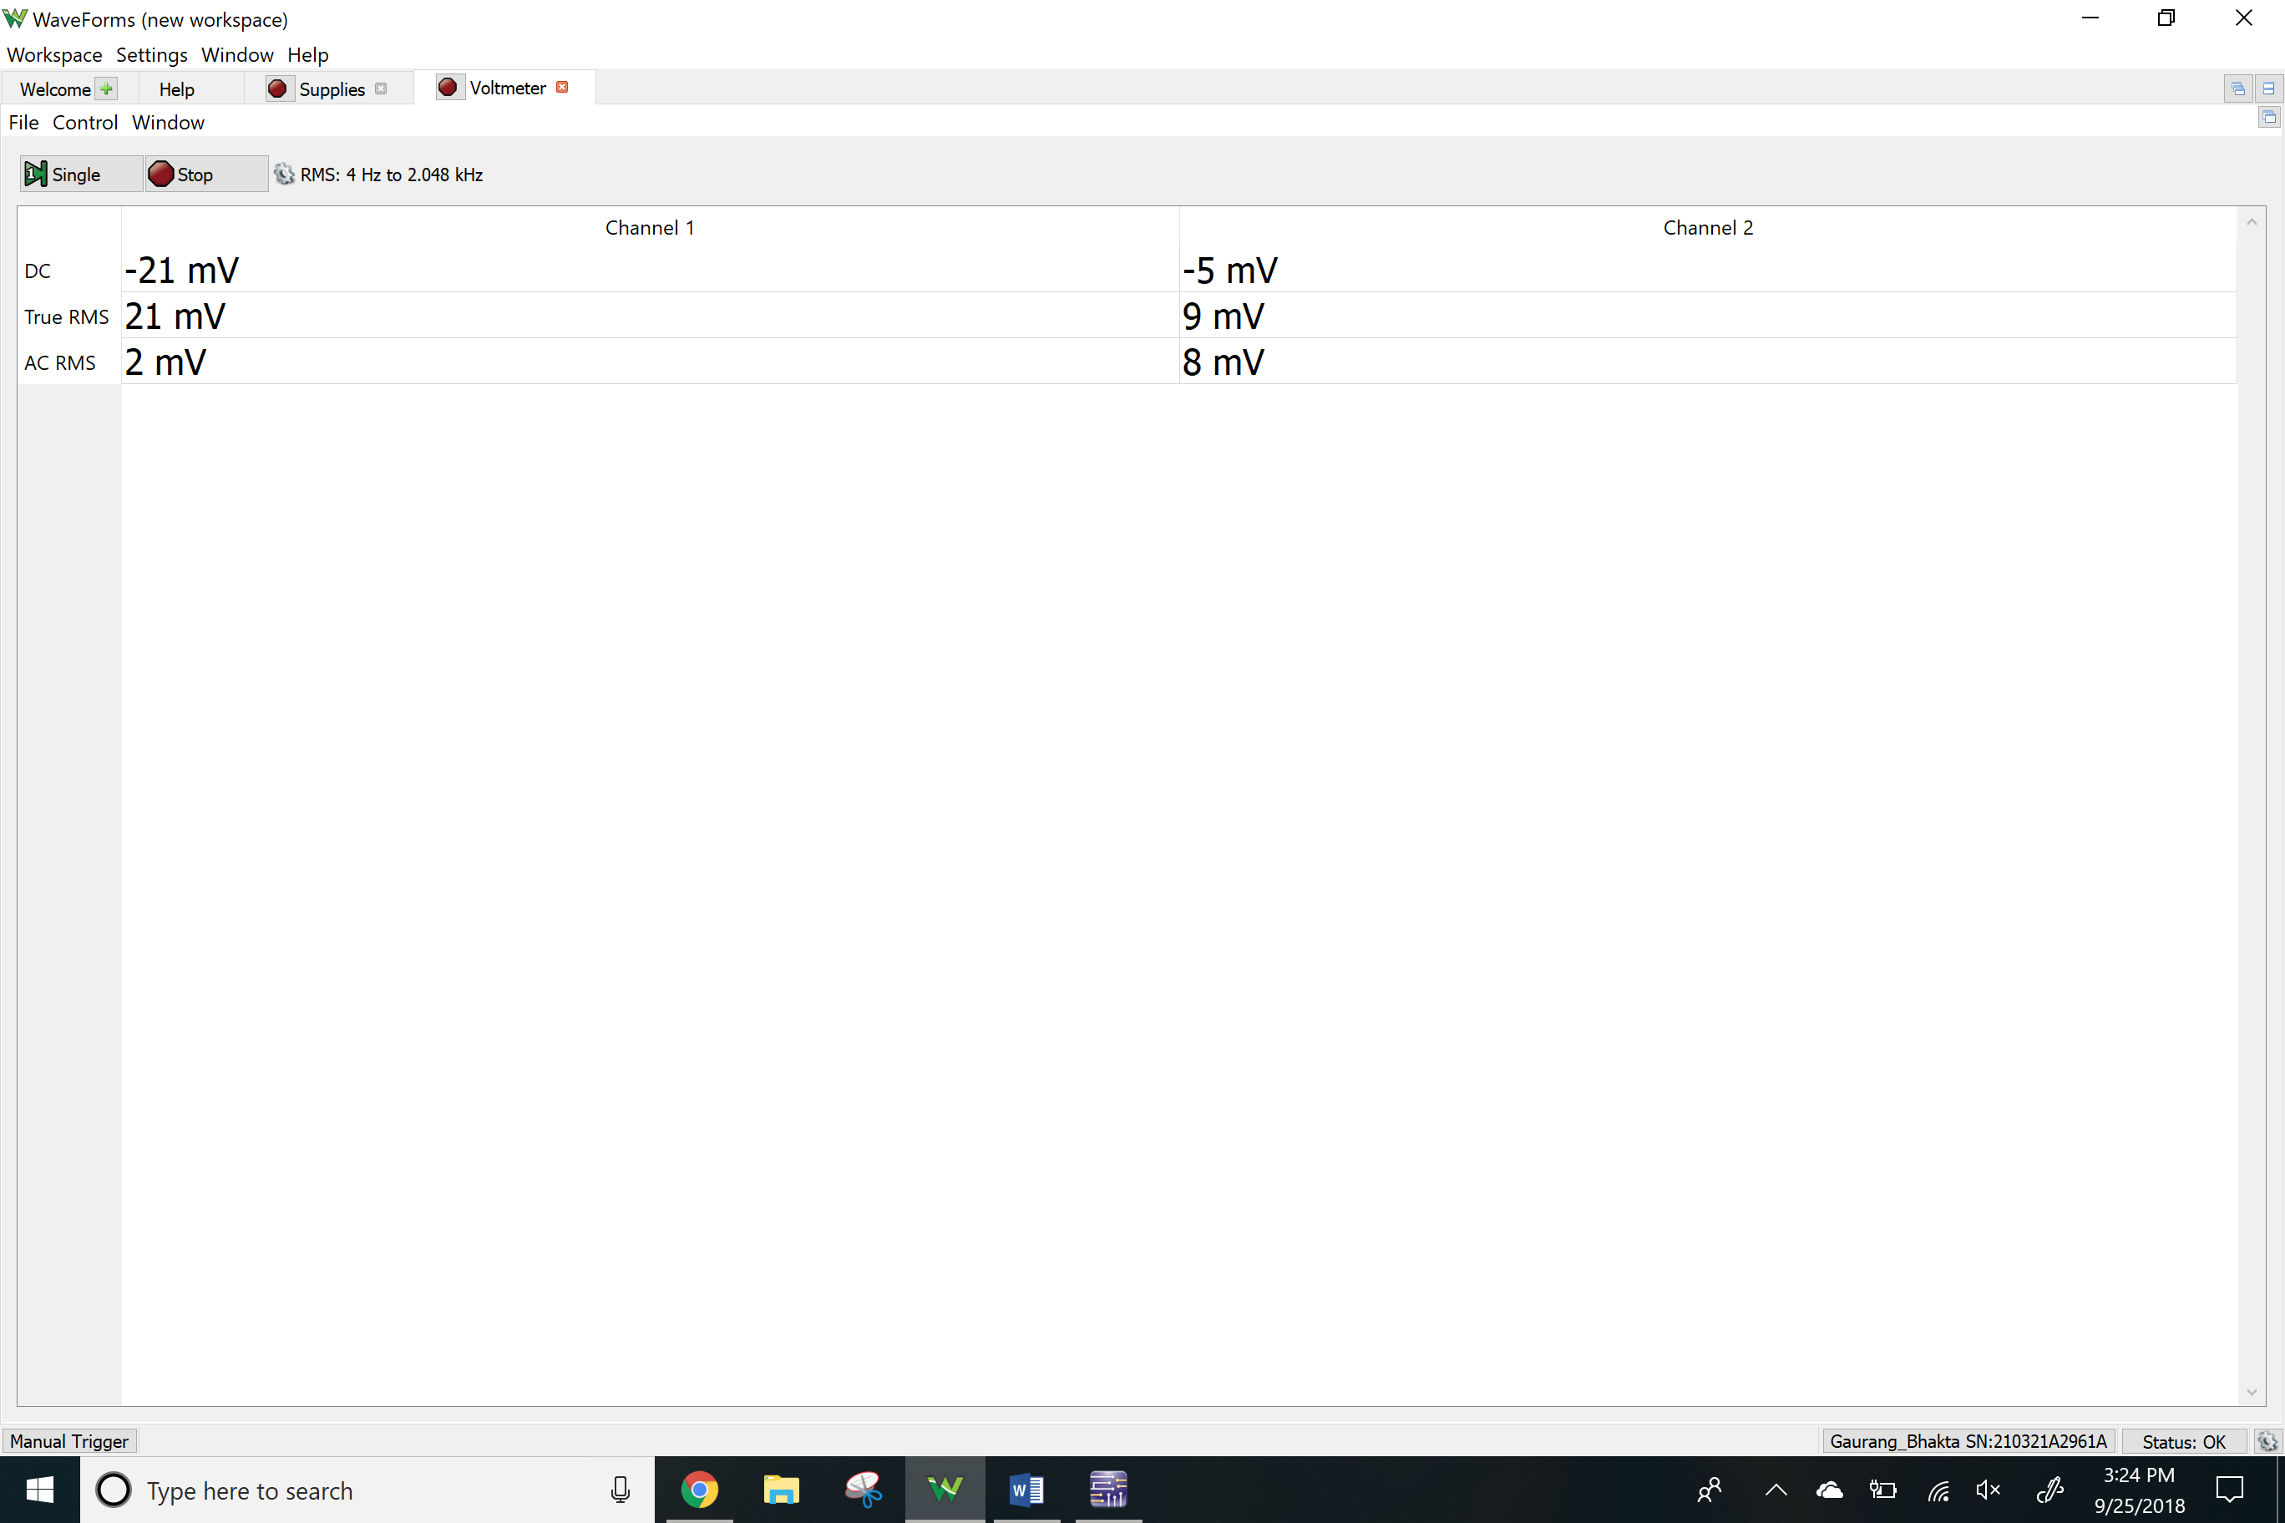

Negative Terminal

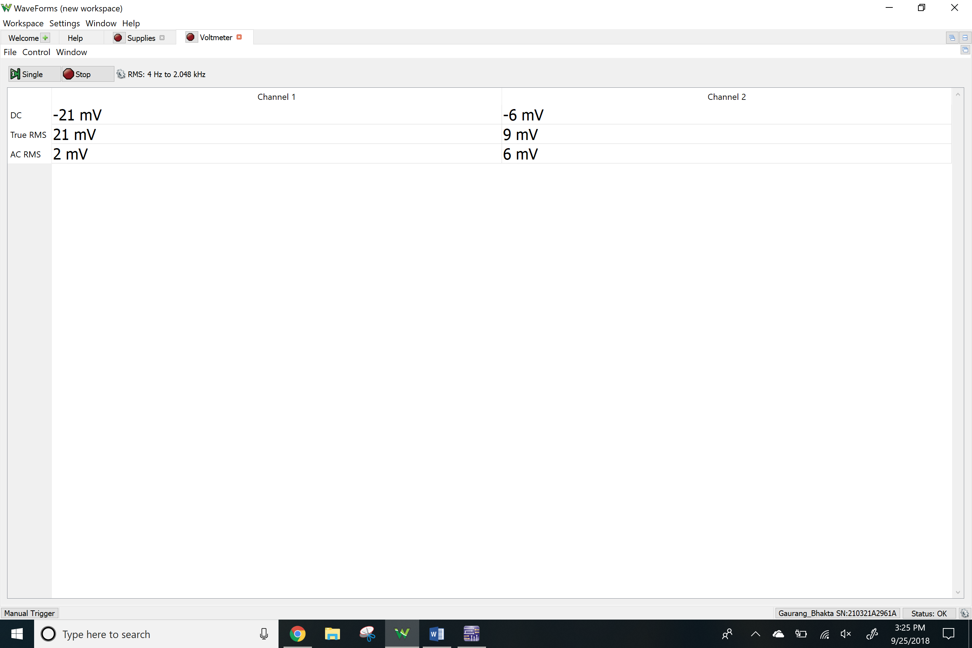

DC Offset Voltage (channel 1)

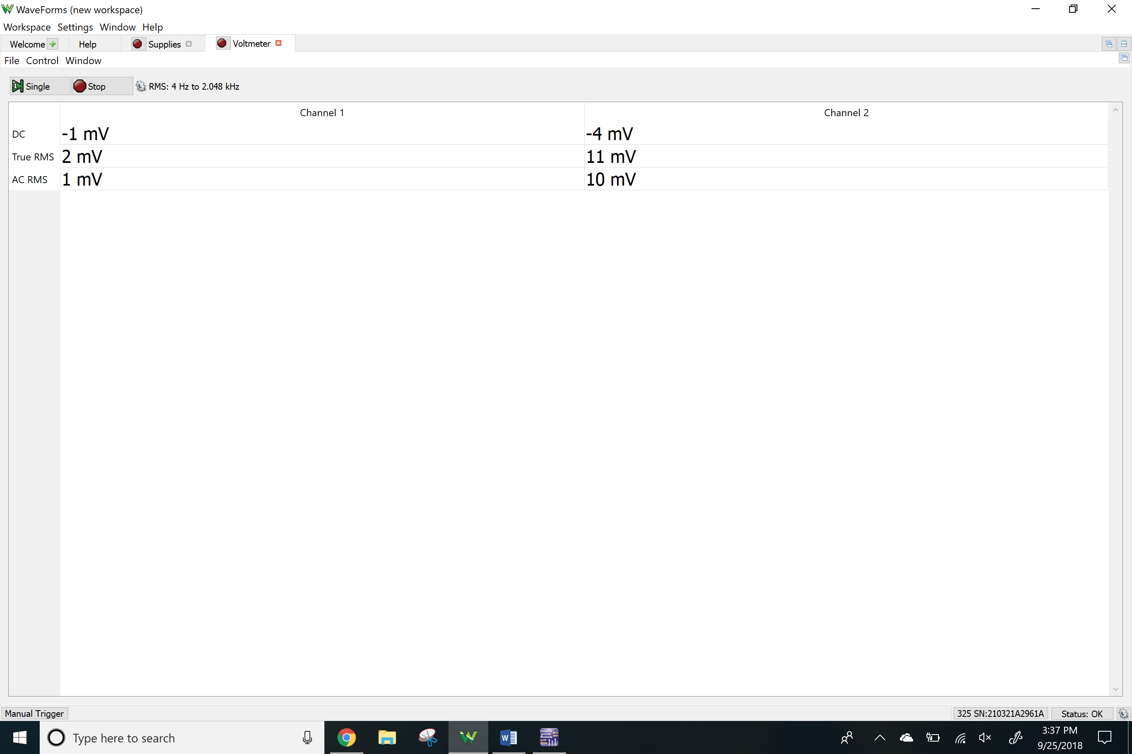

DC offset Voltage compensated (channel 2)

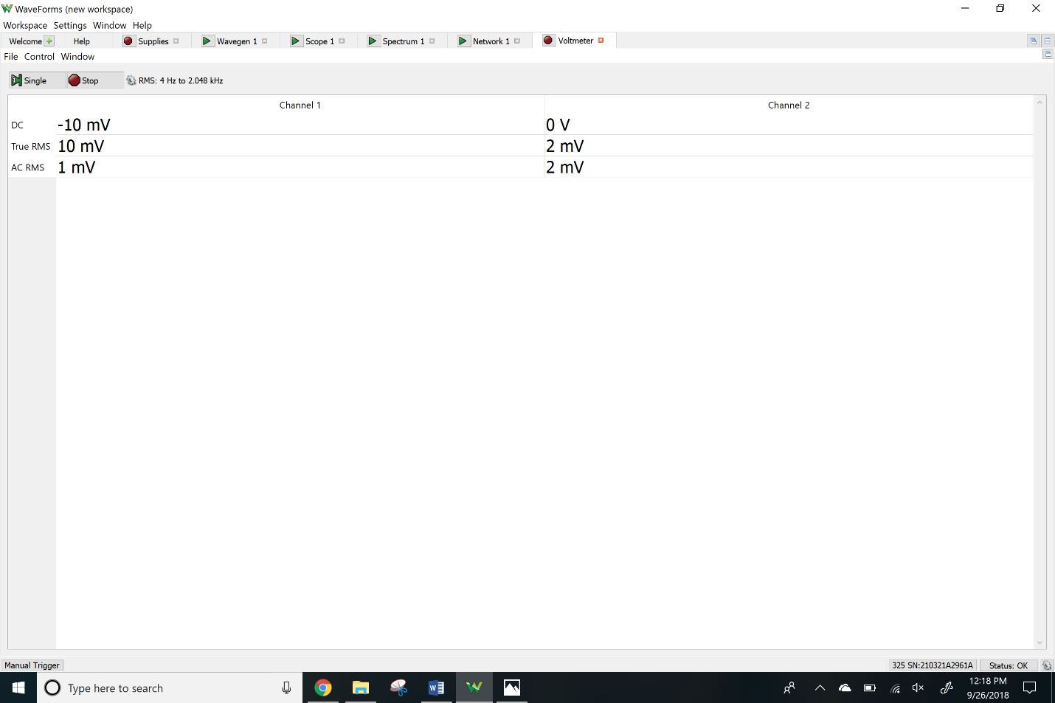

**Inverting and Non-Inverting Configurations**

*Inverting amplifier*

Bode Plots

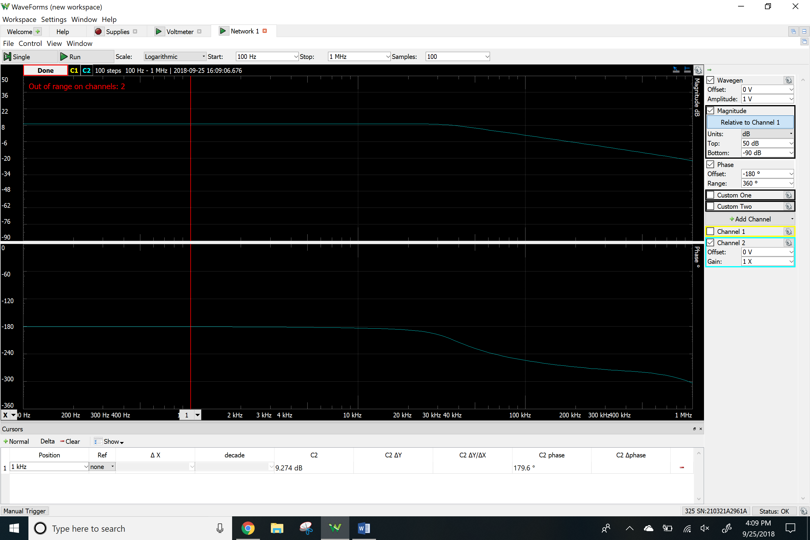

Time-domain waveforms

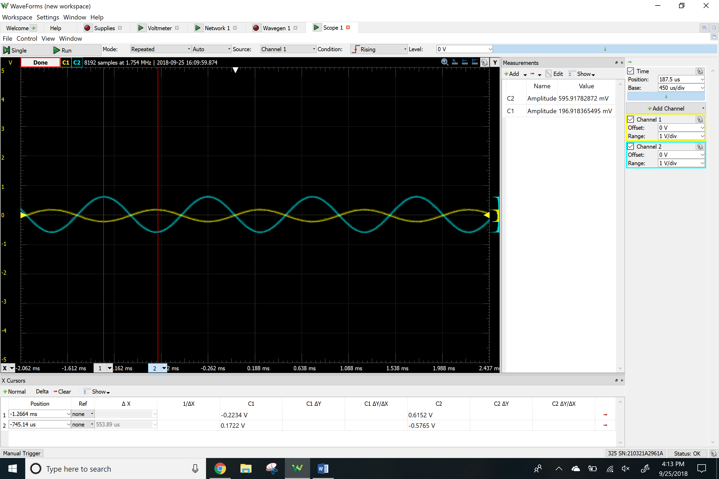

Clipping

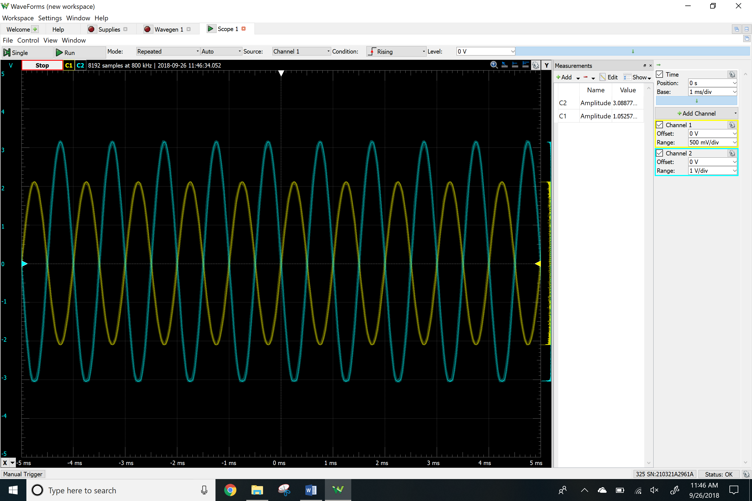

Total Harmonic Distortion

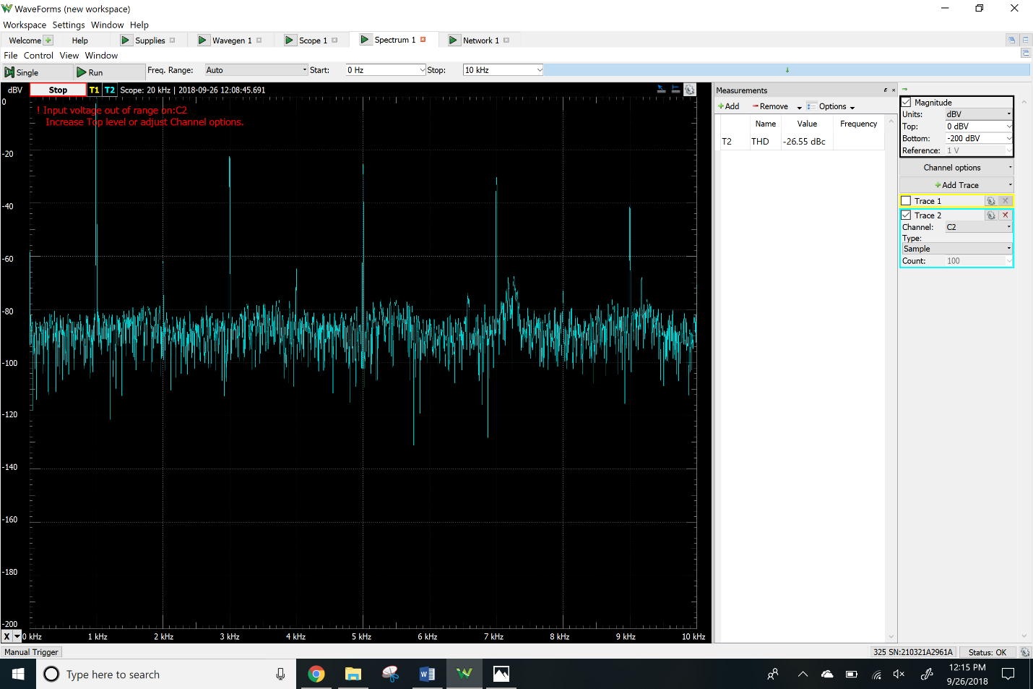

*Non-Inverting Amplifier*

Bode Plots

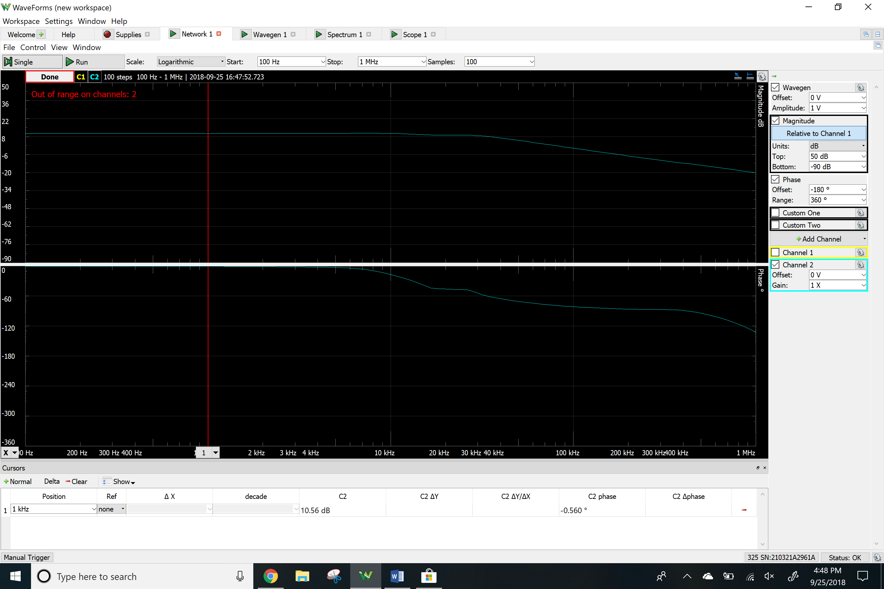

Time-domain waveforms

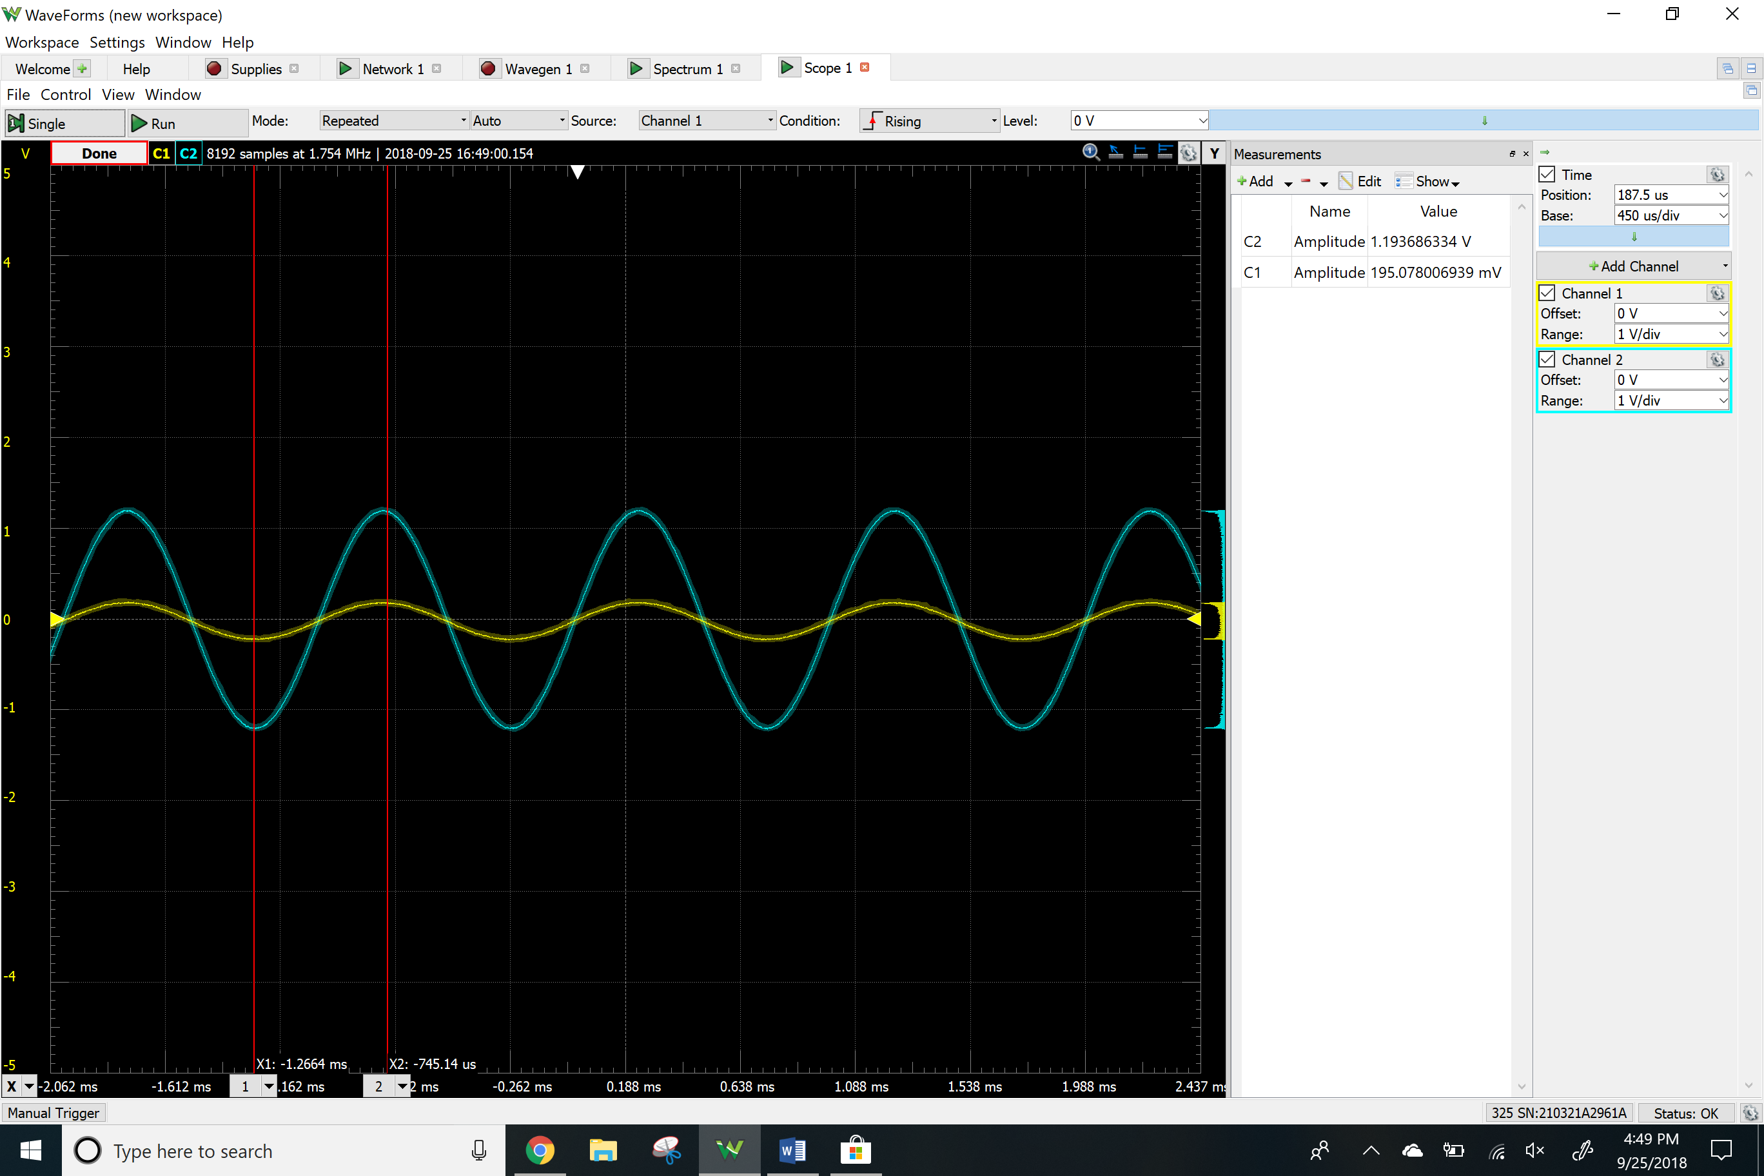

Clipping

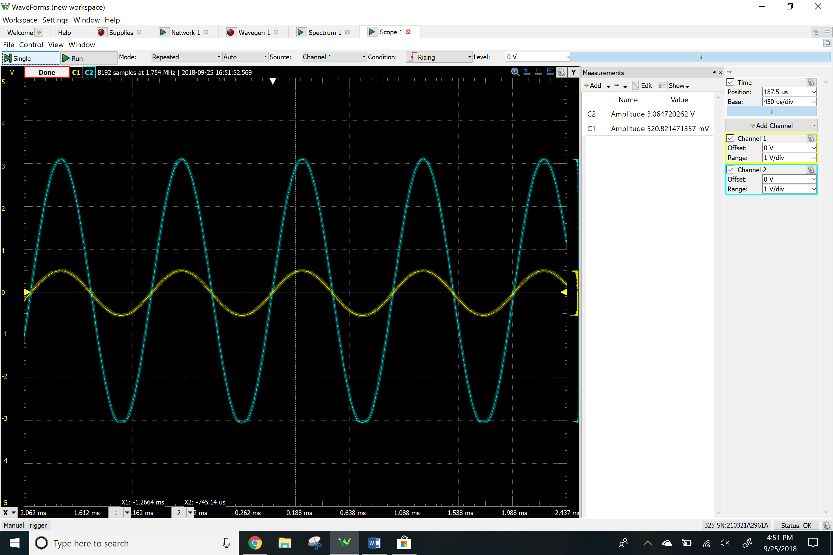

Total Harmonic Distortion

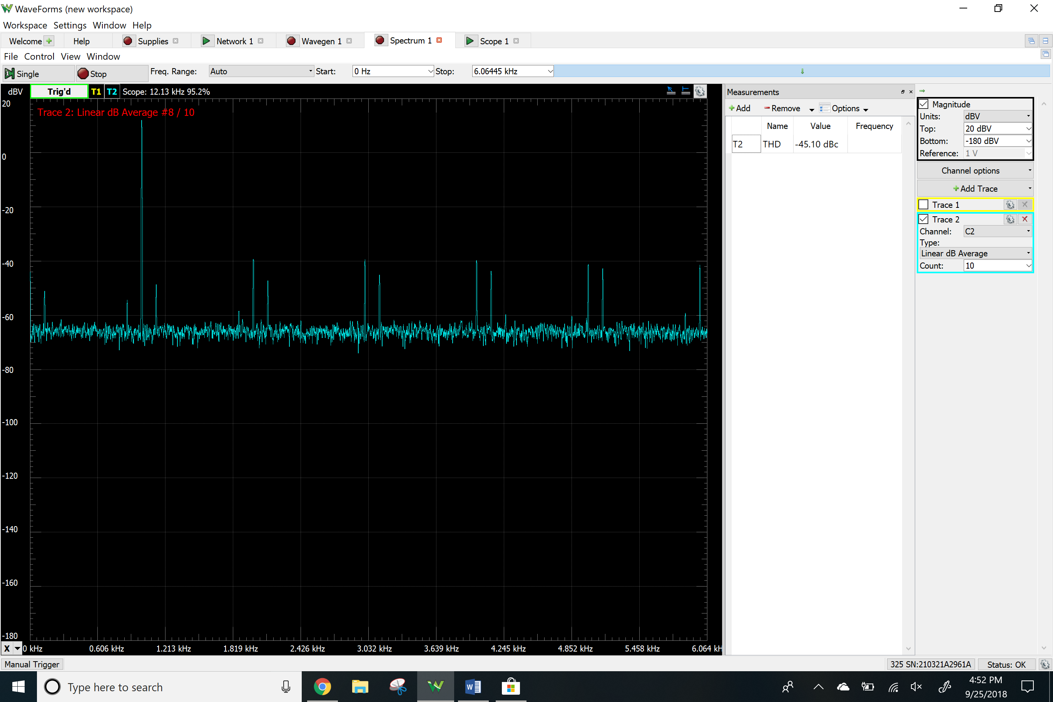

Voltage follower

Bode Plots

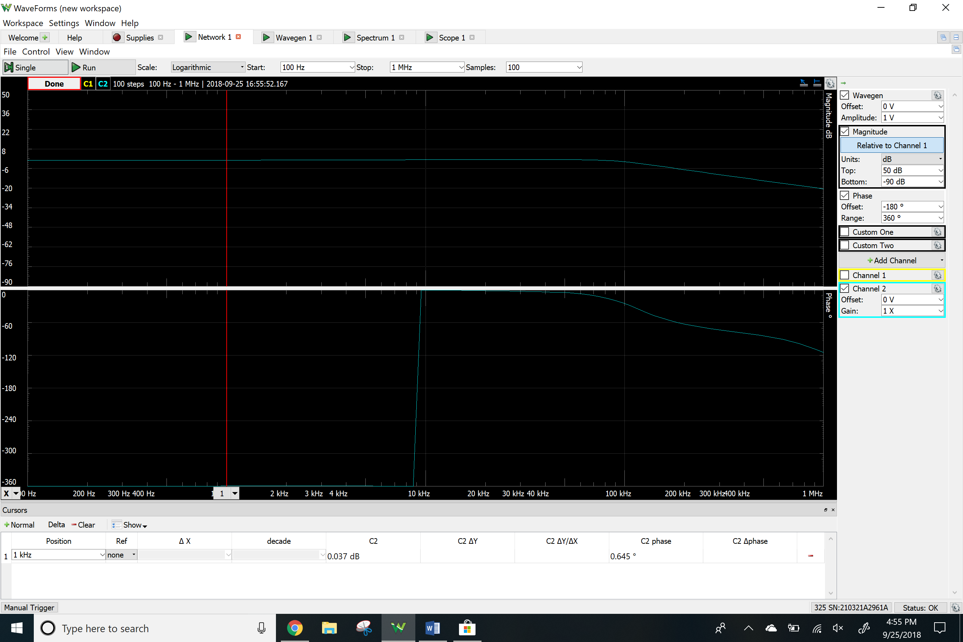

Time-domain waveforms

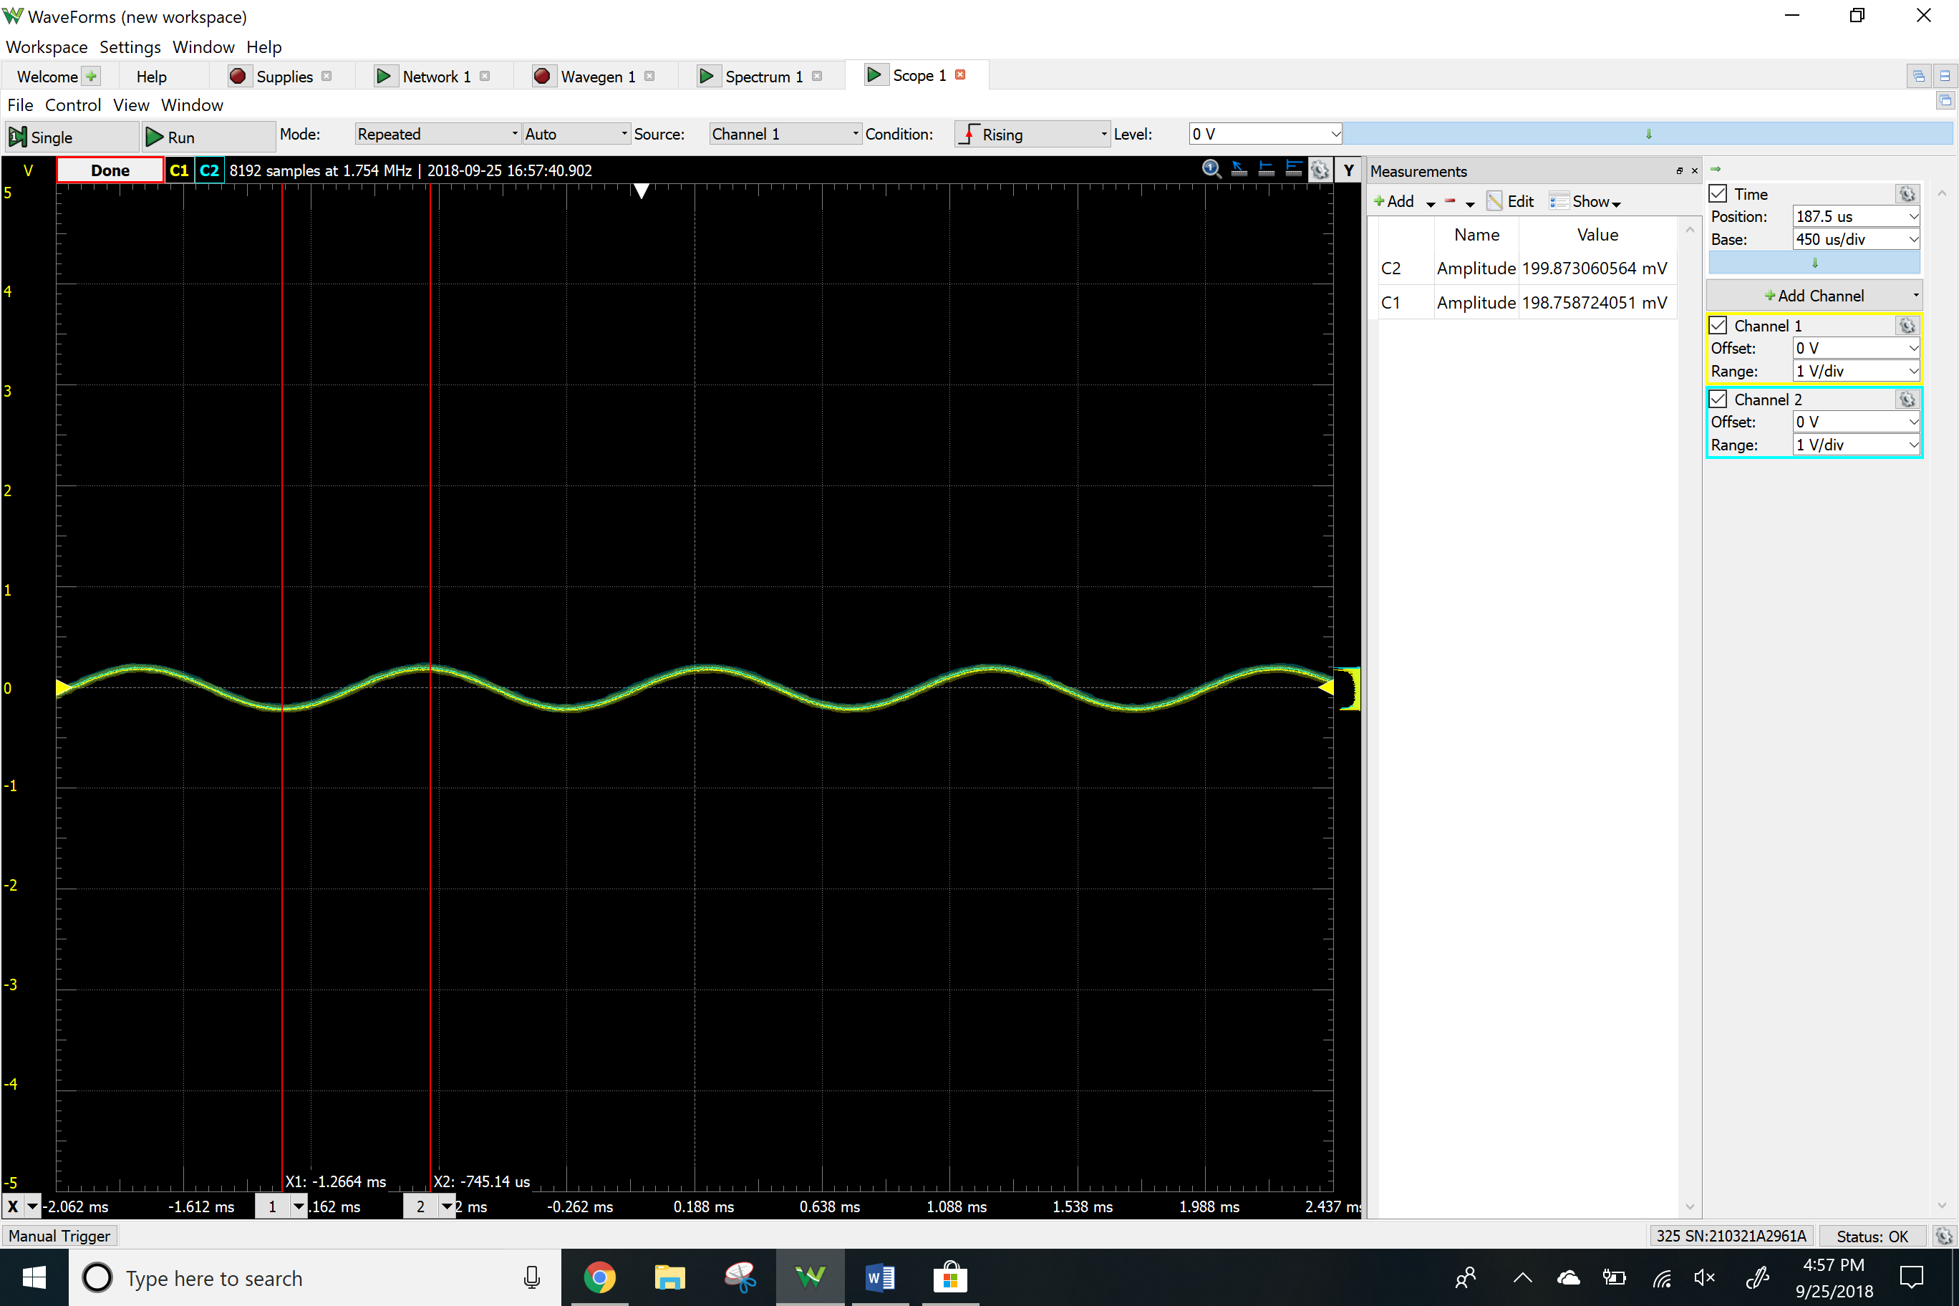

Clipping

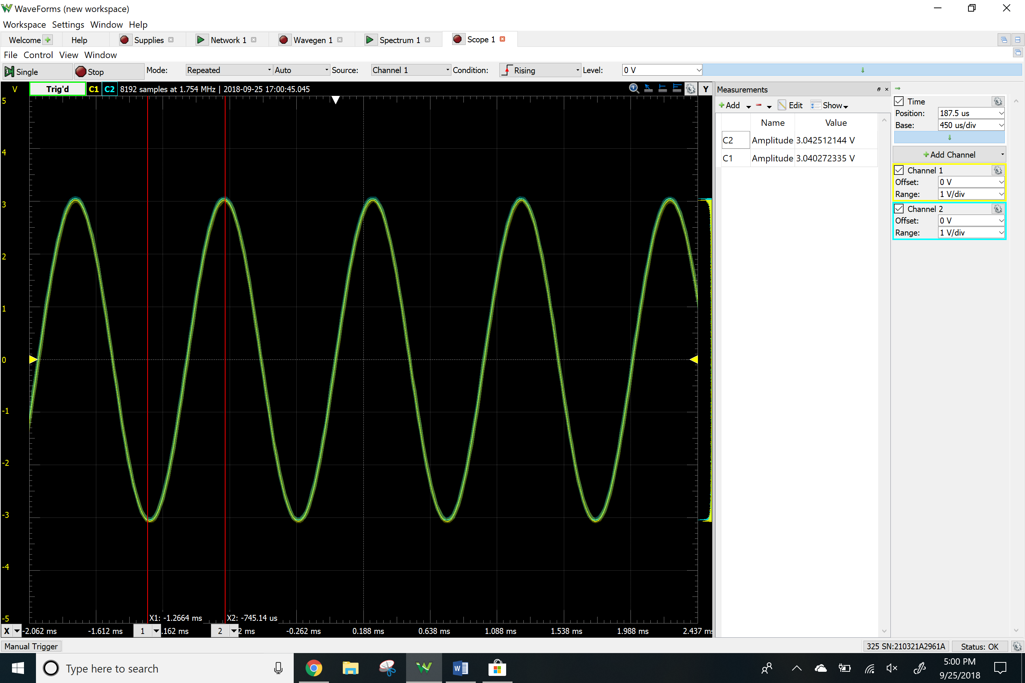

Total Harmonic Distortion

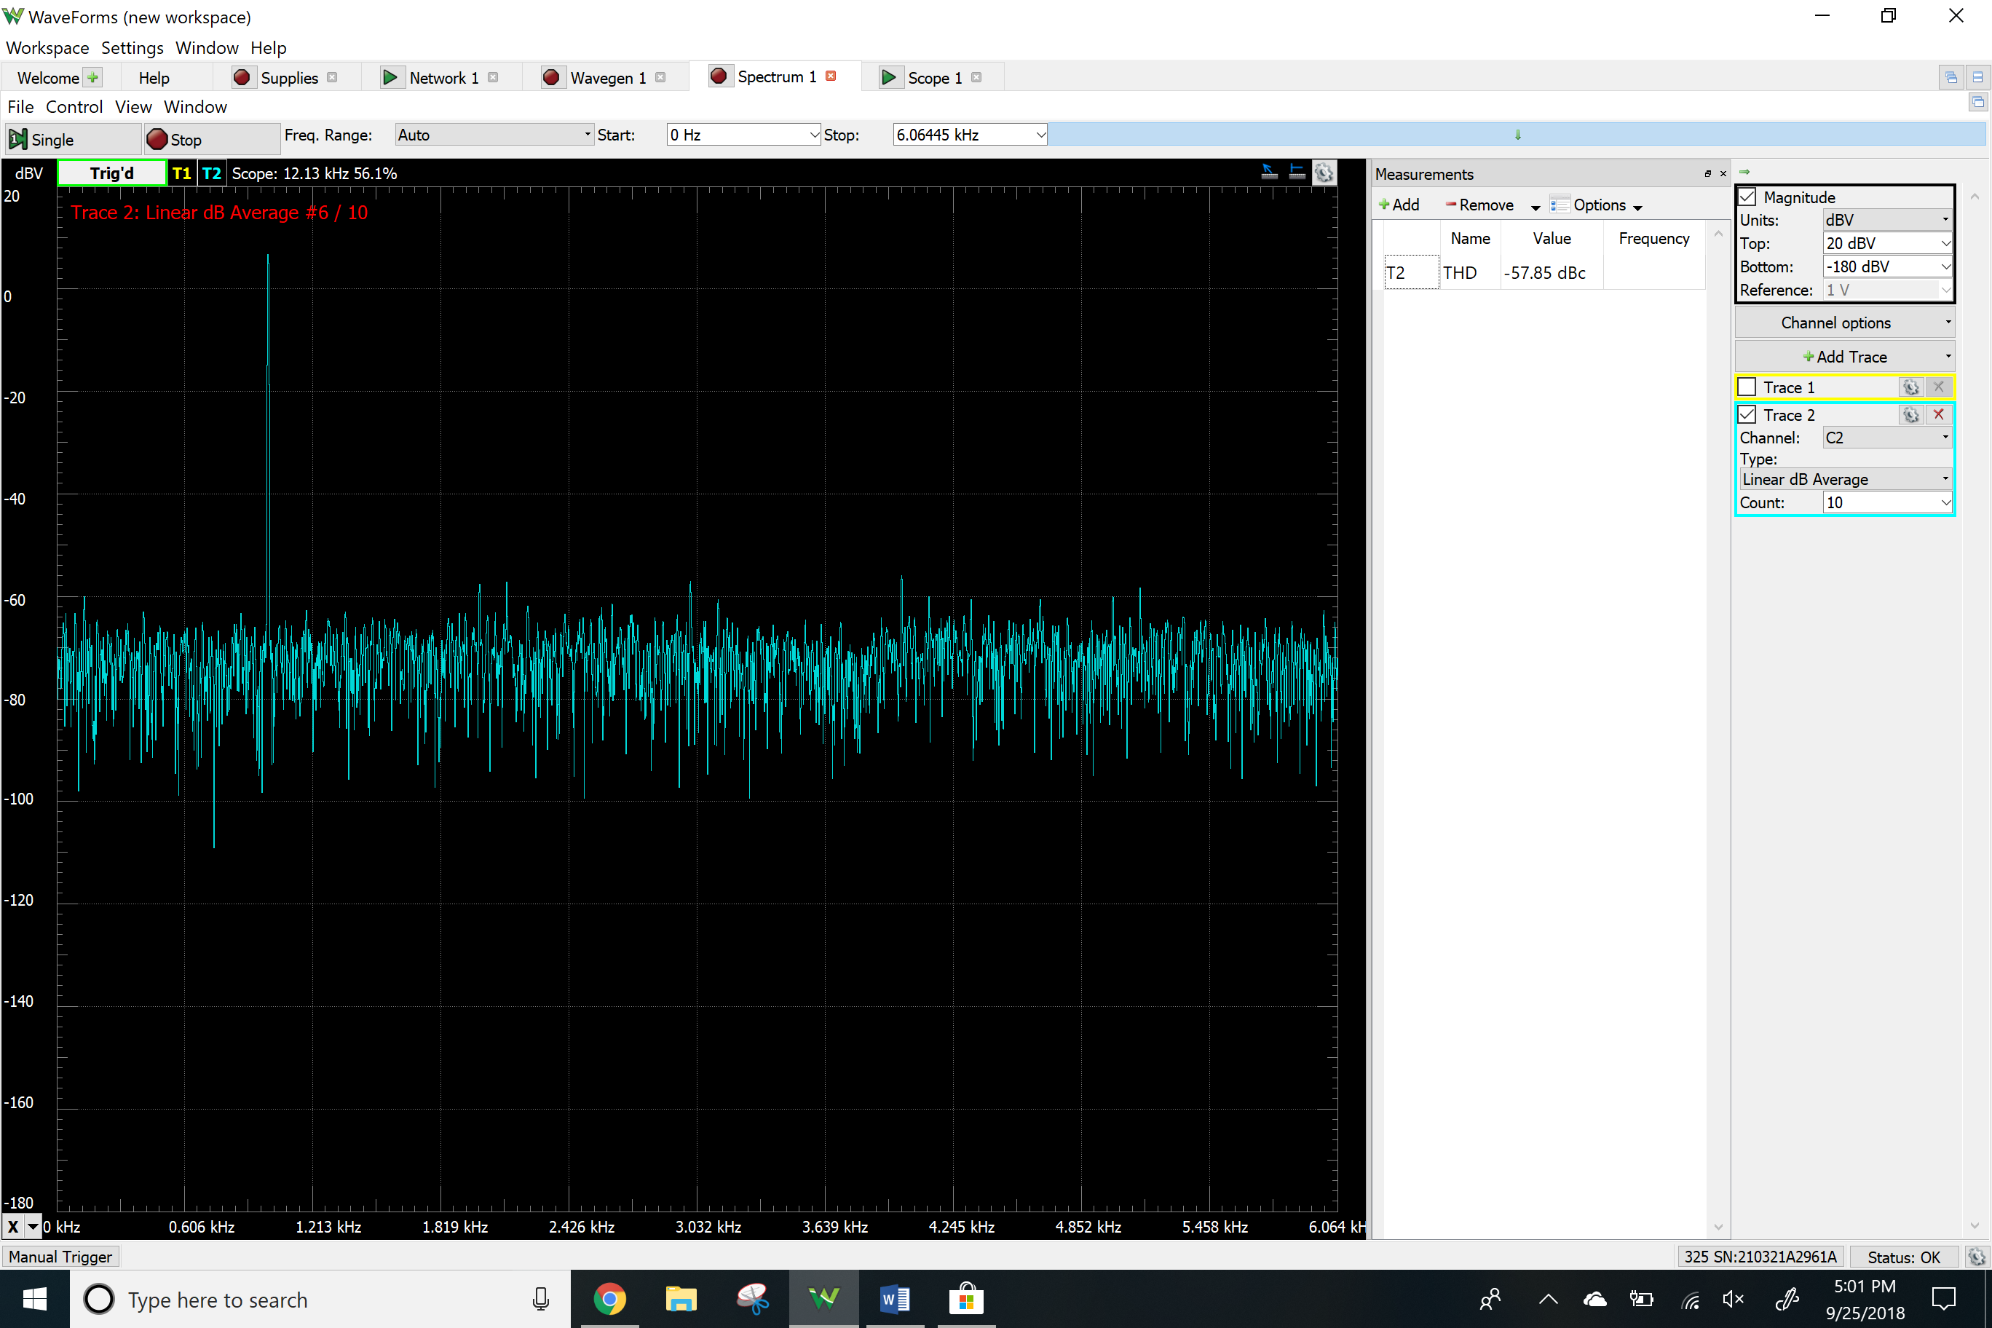

**Table**

Calcultaions part –

|  |  |  |  |
| --- | --- | --- | --- |
|  | **Inverting** | **Non-Inverting** | **Voltage Follower** |
| **Gain at 1kHz** | -3 | 6 | 1 |

Simulations part –

|  |  |  |  |
| --- | --- | --- | --- |
|  | Inverting | Non-Inverting | Voltage Follower |
| Gain at 1kHz (dB) | 9.5422 | 15.5625 | -316.78u |
| Gain at 1kHz (linear) | 2.99992 | 5.9964 | .99971 |
| Phase at 1kHz (degree) | 179.768 | 0 | 0 |
| Resulting gain(transient) | -3.03403 | 6.05 | 1.01 |
| Vimax (V) | 3.7562 | 3.760 | 4.0008 |
| THD % | 29.7289 | 38.5863 | .0007 |

Gain dB to Linear = 10^(db/20)

Measurements –

Input Offset Current

|  |  |  |
| --- | --- | --- |
|  | Positive Terminal | Negative Terminal |
| Voltage | 21mV | 21 mV |
| current | 2.1e^-7 A | 2.1e^-7 A |

DC Offset Voltage

|  |  |
| --- | --- |
|  | Channel 1 |
| Voltage | 2 mV |

Input offset Voltage - 2mV/6 = .000333

|  |  |  |  |
| --- | --- | --- | --- |
|  | Inverting | Non-Inverting | Voltage Follower |
| Gain at 1kHz (dB) | 9.274 | 10.56 dB | .037 |
| Gain at 1kHz | 2.90871 | 3.37 | 1 |
| Resulting gain(transient) | 3.03 | 6.11 | 1.005 |
| Vimax (V) | 1.05 | .520 | 3.04 |
| THD in dbc | -26.55 | -45.10 | -57.85 |
| THD in % | 4.70 | .555 | .128 |

THD in % = 10^((THD in dBc)/20)×100%

Conclusion –

For the most part, the measurements of the simulations and the experimental values was pretty close for almost everything except for the THD because in the simulations I used a general 741 op-amp and in the lab we used a 741cp op-amp so thus my vimax is higher in simulations. The values for the input and output offset voltage were close to what they were supposed to be on the datasheet. The input offset current was close as well. For the gains of each of the circuits, the simulations were almost the same as the experimental values. Any other differences between them could be due to variable resistances within the breadboard itself and the sensitivity of the analog discovery device. The big difference came to the maximum input voltages. The maximum voltages were much higher in the simulation than in the experimental plots. This is because while the positive amplitudes were generally the same, the negative portion of the amplitude was clipped at a much lower voltage. This also carried over to the voltage follower. It can only be concluded that the op amps are not the exact same physically as they are on the simulations. For the distortion measurements, the level of distortion was relatively low for all three circuits with the highest level of distortion coming from the inverting op amp at 4.70% in the measurement values. This means that if these op amps were used in any signals environment, they would not produce much noise and their signals would still be relatively clear.